Asimov, Young Extraterrestrials Harper & Row 1984 Stated First Ed Full print line. Ex-Libris Fine unclipped dust jacket price $10.89 with mylar pasted to the book could be separated but has library tag on spine. Fine hardcover library binding with all 240 pages tightly bound and no marks other than library stamp on acknowledgement page and the pocket on the page before the inside of the back cover. 8vo 7 3/4" to 9 3/4" tall; Cover art by Fred Marcellino ISBN 0060201681
ID 000345 Price $15 Box 7
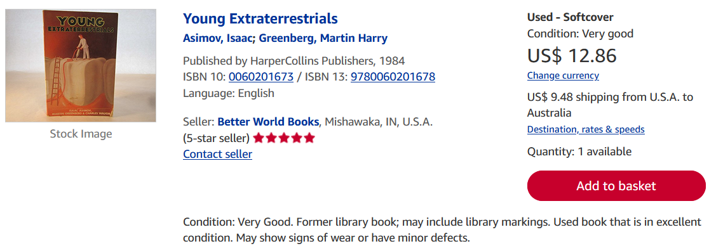
AbeBooks

